Classic Car Signals

Operator Instructions

# Introduction

This project was generated from the need to equip classic cars, which at the time of manufacture lacked turn signals, with a temporary lighting system while they are operating on the road. While in many jurisdictions this is not a necessity, it will add a safety margin for the driver and passengers when travelling surrounded by other modern vehicles.

Once arrived at the destination, the temporary lighting system can be stowed away in its carrying case. This will allow the user to return the car to its original design quickly and without much effort.

# Serial Number

Each system has its own serial number. This serial number defines the matching set of lights and the remote. Lights and remotes from other serial numbers cannot be user-programmed to work un-matched.

# Identifying Modules

The lighting system has five major components: the four signal lights and the remote. They are identified as follows:

|  |  |
| --- | --- |
| * **Module #1** – Front Left Signal Module (FL). * **Module #2** – Front Right Signal Module (FR). * **Module #3** – Rear Right Signal Module (RR). * **Module #4** – Rear Left Signal Module (RL). * **Module #5** – Remote Control Module. |  |

# Setting Up

1. Turn remote on.

***Note:*** It is normal for the FAULT light to remain on while the signal modules connect to it.

1. Turn each of the signal modules on. The order does not matter.

***Note:***The modules will continue blinking until properly connected to the remote. Allow for up to 45 seconds.

1. Once all four signal modules have stopped blinking, the fault light should be off. System is now ready to be operated.

# Operating the system

Operating the system is done by pressing the buttons. Please refer to the below diagram.

## De-bouncing

The system is equipped with software de-bouncing of the buttons. Each button must be held down deliberately for about 250ms before the remote will engage the feature. This prevents signals from being activated too easily if the remote is dropped.

## Off State

In this state all light modules are dark and awaiting command. This is the standard mode in which the system will boot up every time.

**IMPORTANT:** The OFF state is the only state that allows the marker lights to be turned on or off. This is done by holding the *CANCEL* button for 3 seconds.

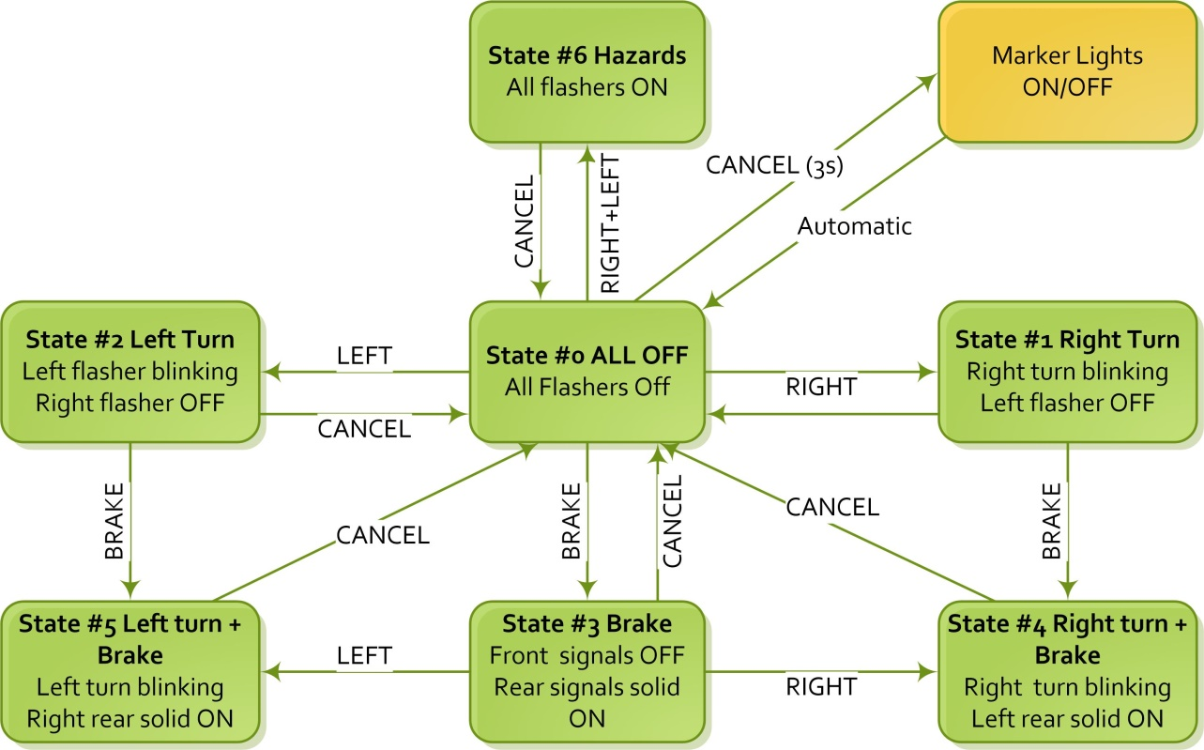

CANCEL

# Additional Information

While the below information is not crucial to the operation of the system, it may provide some insight during troubleshooting.

Before attempting any troubleshooting, ensure the offending module has new batteries installed. A lot of intermittent problems can occur due to depleted batteries.

## The Remote Module

The Remote module is equipped with two LEDs: FAULT and ACTIVITY. At power-up both LEDs should come on followed by both of them going off. After about five seconds the fault light will come on. This indicates that the module has booted and is looking for the signal modules. If it does not find all four modules within 15 seconds it will reboot again and commence looking for signal modules again. The system **WILL NOT OPERATE** without all four signal modules present.

### The ACTIVITY light operates as follows:

* If there is any active function (turn signals or brake) it will be blinking.
* If the marker lights are on it will remain lit, blinking when there is another function active.
* If no function is active, it will remain on (solid) if the marker lights are ON and will remain off if the marker lights are OFF.

### The FAULT light operates as follows:

* The fault light will be ON any time one of the signal modules cannot be reached.
* If the fault light is on for more than 15 seconds, the remote will RESET allowing all the signal modules to re-connect. This situation is highly undesirable during road travel – this is why fresh batteries are always recommended in the signal modules.

## The Signal Modules

The signal modules use the marker lights LEDs to indicate state. When the batteries are first inserted, all the LEDs will come on. After about one second the turn signal LEDs will shut off and the marker LEDs will start blinking. They will continue blinking until a connection is established to the remote. If a connection is not established within 10 seconds, the module will reboot again. This process will continue until a good connection is established. When all the lights are off the module is properly connected.

## Range

The signal modules should be within 50 meters of the remote module when the remote is inside a vehicle. In open areas, where there is no metal between the remote and the signal modules, that distance may be slightly more.

## Interference procedure

Under normal conditions, interference should not be a problem. If the system encounters interference (a signal module disconnects) the following procedure will occur automatically.

1. The disconnected module will reboot and attempt reconnection. If reconnection does not occur within 10 seconds it will reboot and try again.
2. The remote will toggle the FAULT within 2 seconds of a signal module disconnecting. If the offending module does not automatically reconnect in 15 seconds, the remote will reboot causing all the signal modules to reconnect to is as if it was just turned on.
3. Keep in mind that while connection is in progress the marker lights are blinking on the signal modules and the FAULT light will remain on.
4. Normally the situation resolves itself within 10-20 seconds.

If the above keeps occurring, it could also be a sign that one of the signal modules (or remote) is out of batteries. Replace all batteries at once for best result.

## Emergency Mode

The above mode of operation will not allow the system to function without all four Signal Modules being present and operational. This requirement can be circumvented by the following steps:

1. Ensure remote is OFF.
2. Ensure all available Signal Modules are ON.
3. Hold BRAKE button while turning the remote ON.
4. The signal modules will connect to the remote.
5. Even if not all modules are connected the remote will not issue a global reset command. It will operate with the available modules. If not all modules are connected, the FAULT light will remain on.

Using this procedure, an offending Signal Module can be identified since it will either remain OFF or keep blinking attempting to reconnect. Replace batteries in the offending module and try again by restarting the whole system. If the Signal Module remains unresponsive, it is most likely defective.